EG End-Sem exam Question Paper
Q1. Orthographic projection and section of solids
Problem 1: A hexagonal prism of side base 30mm and length of axis 75mm, is resting on a corner of its base on H.P, with the longer edge containing that corner, inclined to H.P at 30°. It is cut by a section plane parallel to H.P and passing through the mid-point of the axis. Draw the front and sectional top views of the solid.
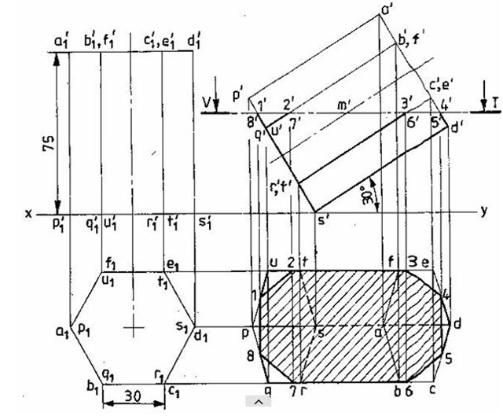
Simple position: 5 Marks
Inclined Position: 5 Marks
Naming the points: 5 Marks
Sectional View: 5 Marks

Problem 2: A square pyramid base 40 mm side and axis 65 mm long has its base on HP and all the edges of the base are equally inclined to VP. It is cut by a section plane perpendicular to VP and inclined at 45⁰ to HP and bisecting the axis. Draw its sectional plan, sectional end elevation and true shape of the section.
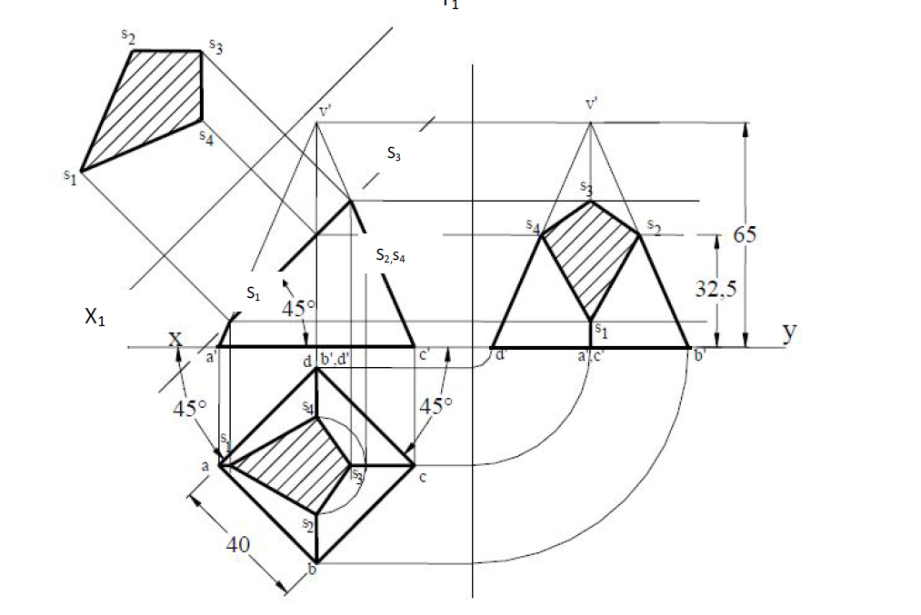
Simple position: 5 Marks
Inclined Position: 5 Marks
Naming the points: 5 Marks
Sectional View: 5 Marks

Q2. Orthographic projection of objects
Problem 1: Draw the top and front views of a rectangular pyramid of sides of base 40x 50 mm and height 70 mm when it lies on one of its larger triangular faces on HP. The longer edge of the base of the triangular face lying on HP is inclined at 60° to VP in the top view with the apex of the pyramid being nearer to VP.
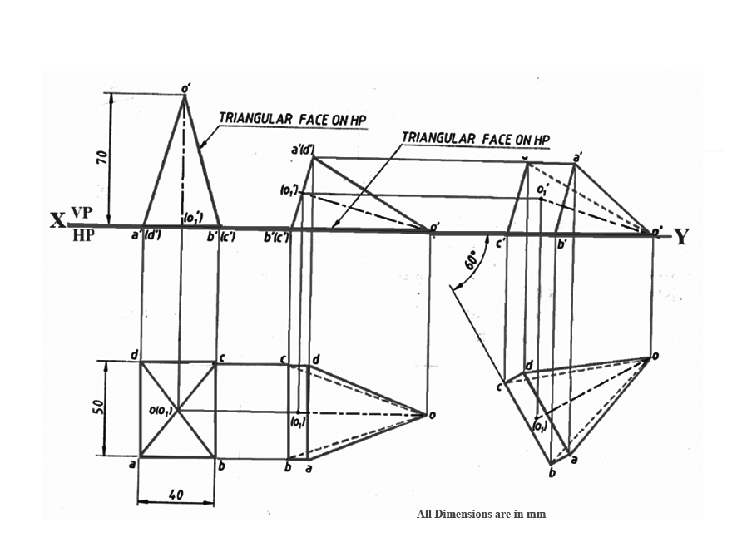
Simple position: 5 Marks
Inclined Position : 15 Marks
Naming the points: 5 Marks
Problem 2: A pentagonal prism of 25mm base side and 50mm axis length is resting on the HP on one of its base corners with its axis inclined at 400 to the HP and parallel to the VP. Draw its projection when the base sides containing the resting corner are equally inclined to HP.
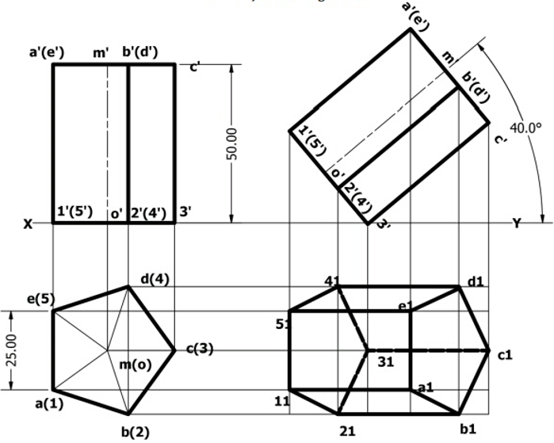
Simple position: 5 Marks
Inclined Position : 15 Marks
Naming the points: 5 Marks

Q3 Isometric view of objects

Problem 1:

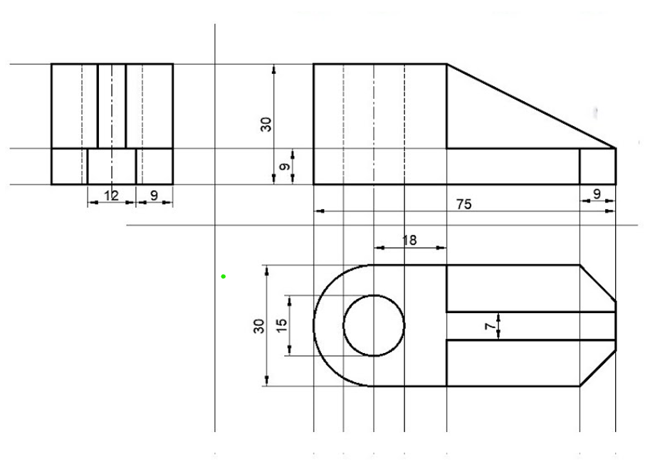
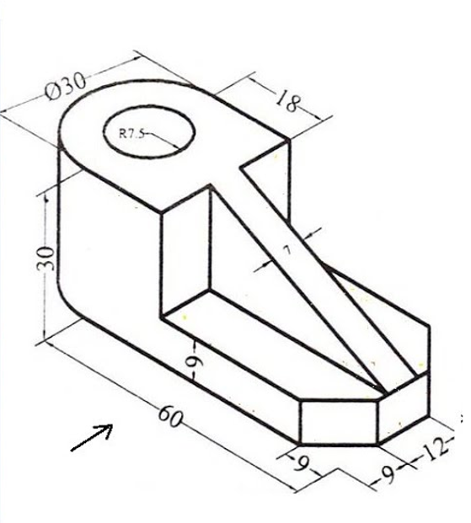
Isometric projection: 20 Marks
Dimensioning: 5 Marks

Problem 2 :
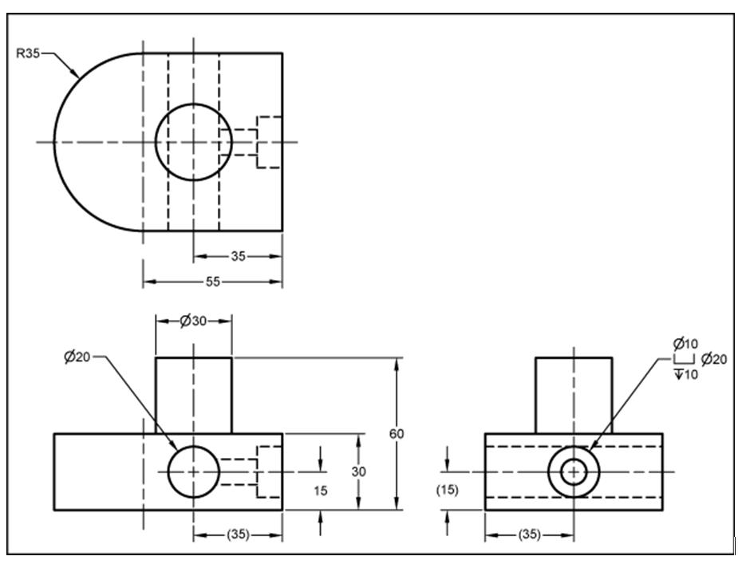

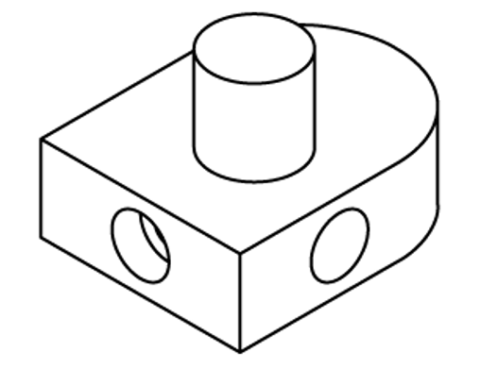
Isometric projection: 20 Marks
Dimensioning: 5 Marks

Q4 Intersection of solids/Development of surfaces
Problem 1: A cylinder 50mm dia and 70mm axis is completely penetrated by a square prism of 25 mm sides and 70 mm axis, horizontally. Both axes intersect & bisect each other. All faces of prism are equally inclined to Hp. Draw projections showing curves of intersections.
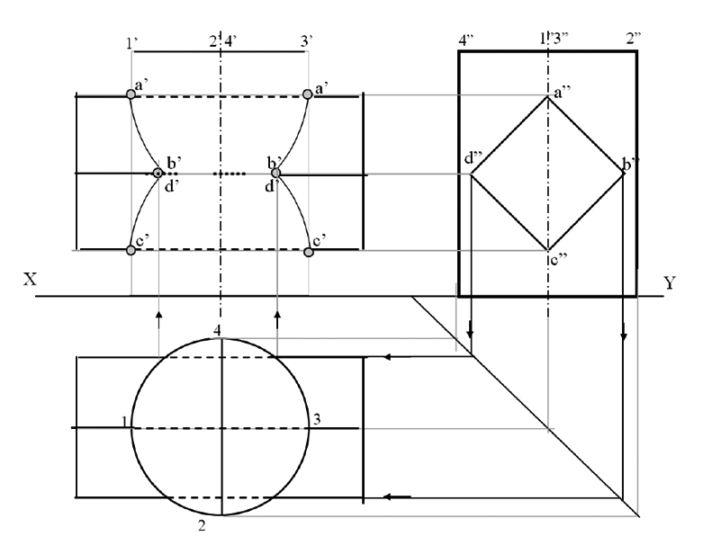
Projection (T.V, F.V and S.V): 15 Marks
Curves of intersections: 5 Marks
Naming the points: 5 Marks
Problem 2: A solid composed of a half-cone and half- hexagonal pyramid. It is cut by a section plane 450 inclined to Hp, passing through mid-point of axis. Draw F.v., sectional T.v., true shape of section and development of remaining part of the solid. (take radius of cone and each side of hexagon 30mm long and axis 70mm).
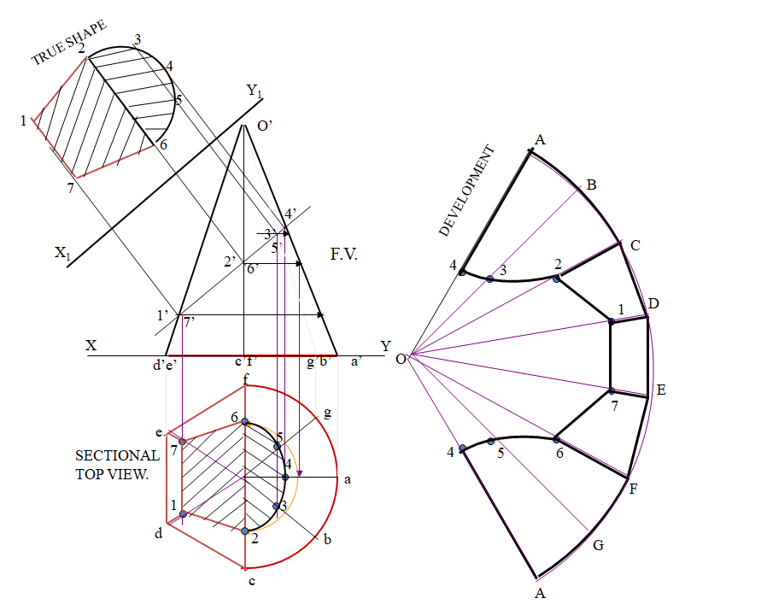
Projection (T.V, F.V and S.V): 5 Marks
Section view : 5 Marks
True shape: 5 Marks
Development of surface: 10 Marks

